8.FOURIER TRANSFORM AND FREQUENCY DOMAIN ANALYSIS
Experiment 8.1
Fourier Transform of Periodic Impulse Train
Aim:
To compute and analyze the Fourier Transform of a periodic impulse train using MATLAB.
The Aim is to observe the frequency-domain characteristics of a periodic impulse train,
which should result in a discrete set of frequency components due to the periodicity of the
signal.
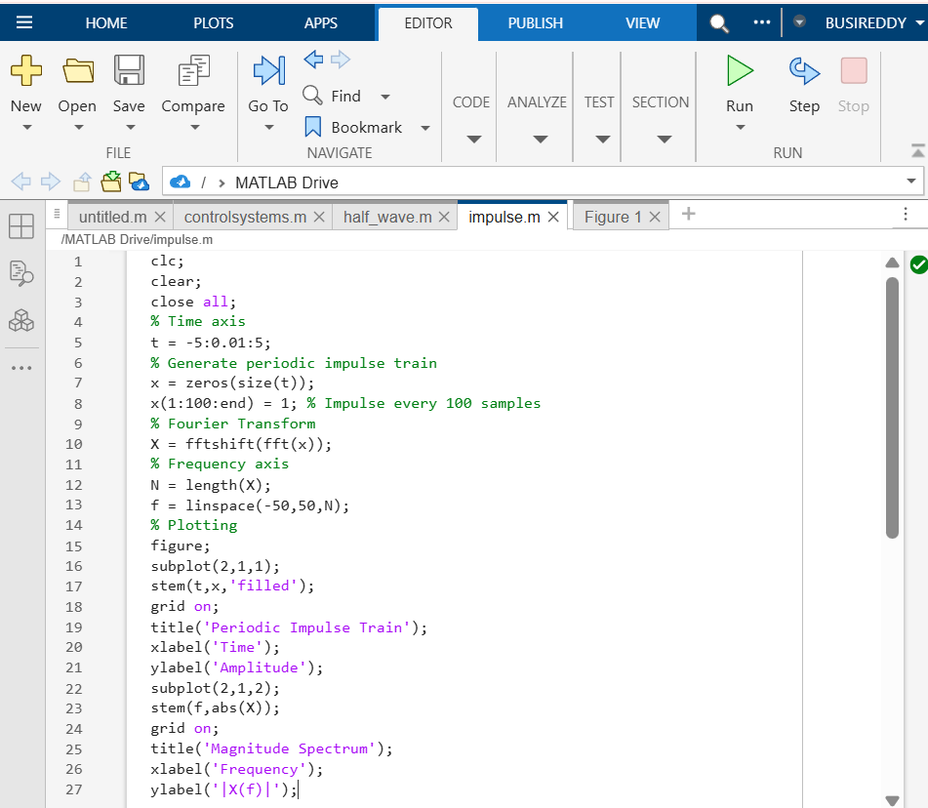
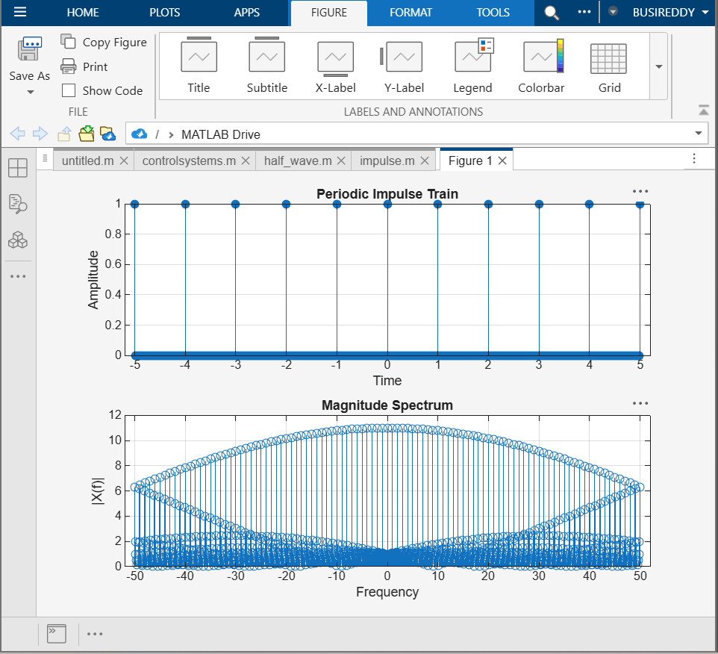
Experiment 8.2
Realization of DIT FFT for Spectral Analysis
Aim
To implement the Decimation-In-Time (DIT) Fast Fourier Transform (FFT) algorithm in
MATLAB for efficient computation of the Discrete Fourier Transform (DFT) and to plot the
magnitude spectrum of a given signal.
